Zack A. Lodi
CSS-499

Milestone Four Narrative - Databases Enhancement

For the Databases enhancement, I replaced the temporary in-memory history system from the original CS-360 project with a fully persistent Room database. The original app stored sensor readings in a static list that was cleared every time the app closed, which made the history feature unreliable and unsuitable for real-world use. To address this limitation, I designed and implemented a complete data persistence layer using modern Android architecture components. This included creating a SensorRecordEntity to define the schema, a SensorRecordDao for structured database operations, a SensorDatabase singleton to manage the Room instance, and a SensorRepository to provide a clean abstraction between the UI and the database. This architecture ensures that the app now stores sensor readings permanently, even across app restarts, and follows best practices for separation of concerns.
The enhancement also required integrating the database into the existing UI workflow. I updated MainActivity so that each smoothed sensor reading is saved to the database with a timestamp, replacing the old HistoryManager entirely. I then refactored HistoryActivity to load records directly from Room and display them in the RecyclerView using an updated adapter that binds SensorRecordEntity objects. I also added support for clearing the database through the existing “Clear History” button. This enhancement demonstrates my ability to design and implement a complete persistence layer, integrate it into an existing codebase, and follow modern Android development patterns.
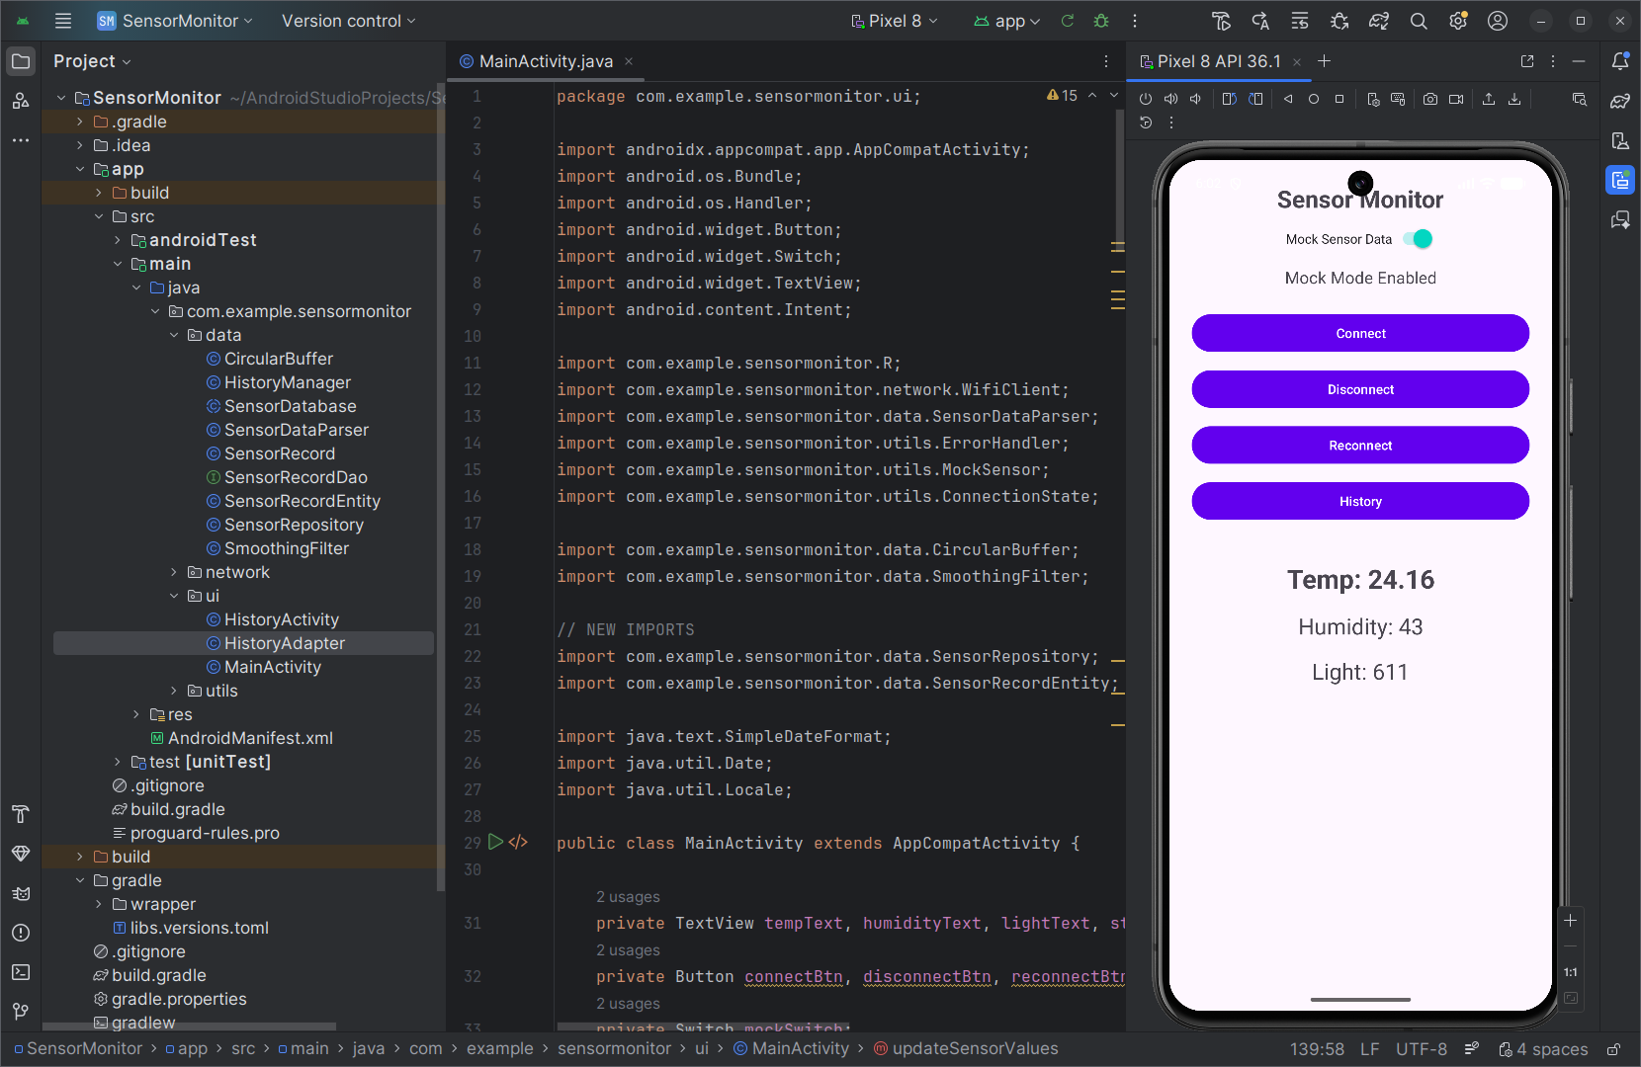

SensorRecordEntity.java
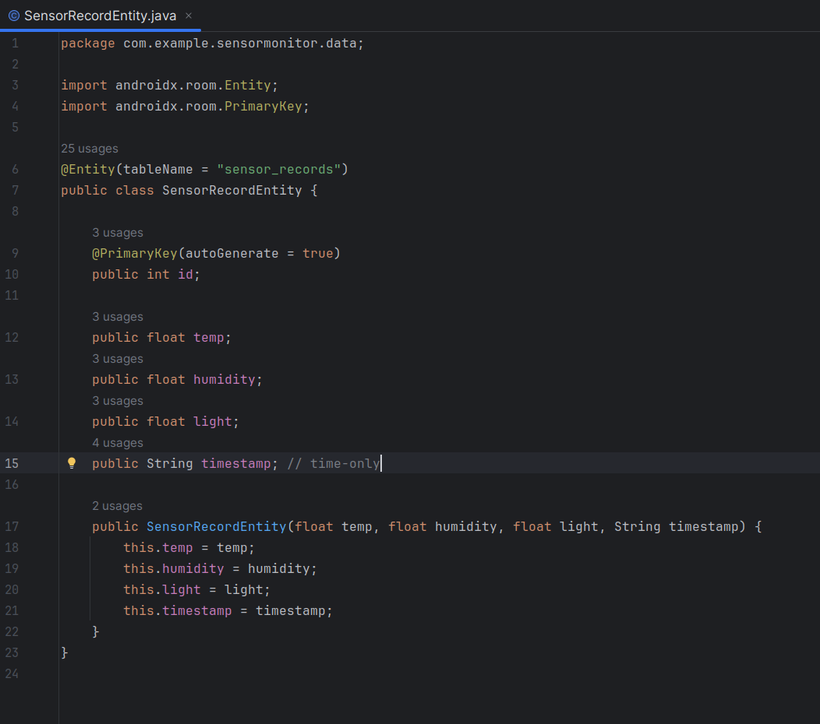

SensorRecordDao.java
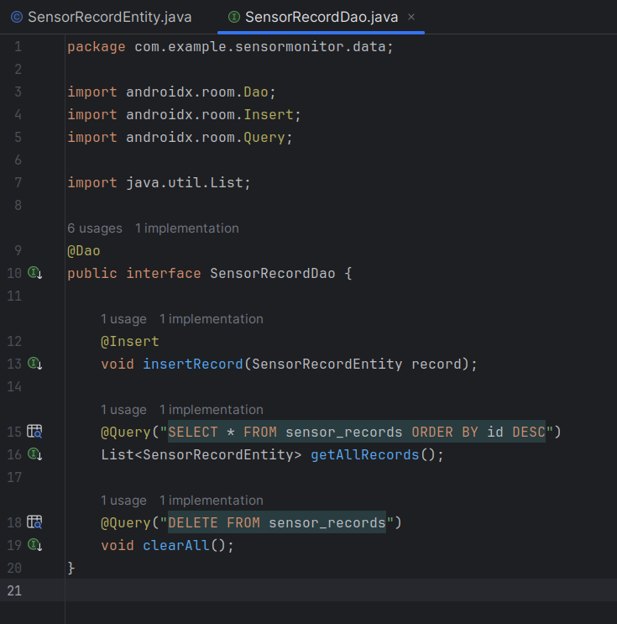

SensorDatabase.java
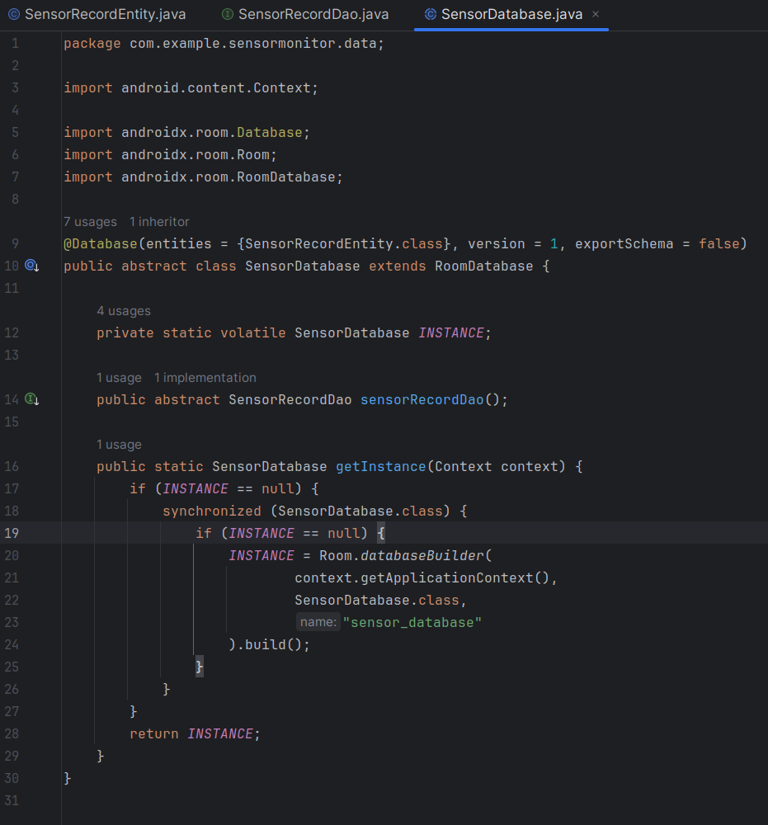
SensorRepository.java
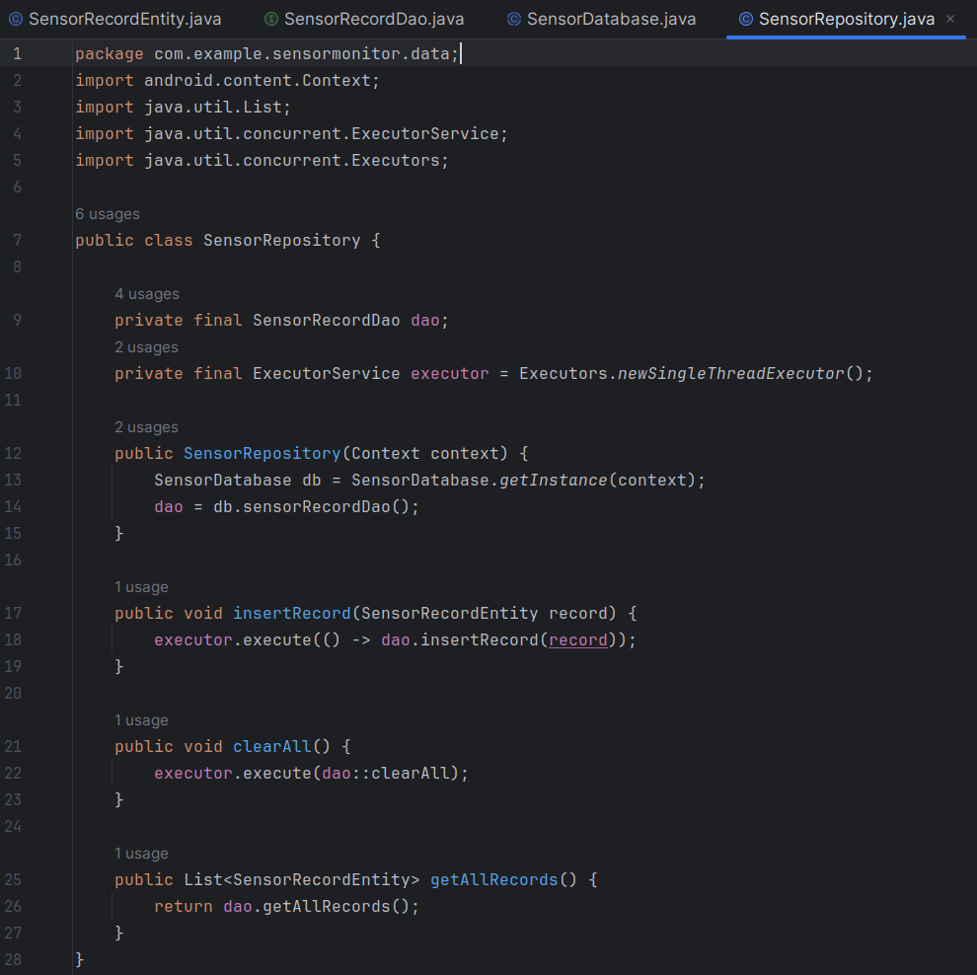
Reflection
Throughout this milestone, I strengthened my understanding of how persistent data storage transforms an application from a simple prototype into a reliable, production-ready tool. Replacing the temporary in-memory history system with a full Room database required me to think more about data modeling, schema design, and long-term maintainability. I also gained experience integrating a repository pattern into an existing codebase, which helped reinforce clean architecture principles and separation of concerns. This enhancement not only improved the functionality and professionalism of my project, but also deepened my confidence in building Android applications that follow modern best practices.

